*Cooking Day!!

* Fruit Face Building
* Water
* Rice Cake
* Cheese Stick
* Water
* Pretzels
* Pepperoni
* Water
* Cottage Cheese
* Peaches
* Water
* Veggie Straws
* Bananas
* Water
* WG Toasted Ham Sandwich
* Applesauce
* Milk
* Chickpea and Cheese Quesadilla
* Strawberries
* Corn
* Milk
* Grilled Cheese
* Tomato Soup
* Apples
* Milk
* Fish Sticks
* Black Berries
* Bell Peppers
* Milk
* WG Hamburger Mac
* Tomatoes
* Apples
* Milk
* WG Cereal
* Turkey Bacon
* Milk
* Greek Yogurt
* Apples
* Milk
* WG Toast
* Hard Boiled Egg
* Milk
* WG Gluten-Free Waffles
* Blueberries
* Milk
* Oatmeal
* Raspberries
* Milk

**SAMPLE**

**Monday**

**Tuesday**

**Wednesday**

**Thursday**

**Friday**

**Breakfast**

**Lunch**

**Snack**

**Week**

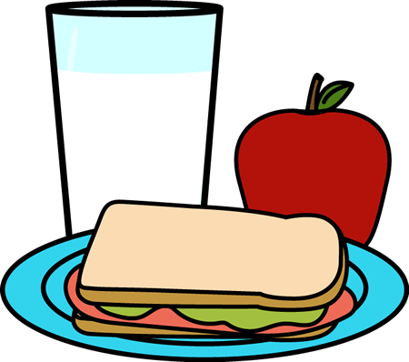

F

O

O

D

M

E

N

U

**TheDaycareLab.com**